Exercise 13:

**1. Describe the Process Step by Step**

**Problem**: Solve the equation ax+b =0, where a and b are real numbers, and a≠0a \neq 0a=0.

**Steps**:

1. **Input values**: Read the values of a and b.
2. **Check if a=0a = 0a=0**:
   * If a=0a = 0a=0, the equation is not valid (not a first-degree equation).
     + If b=0b = 0b=0, the equation is 0=00 = 00=0, which means every xxx is a solution (infinite solutions).
     + If b≠0b \neq 0b=0, there is no solution.
3. **Solve for xxx**:
   * If a≠0a \neq 0a=0, rearrange the equation to x=−b/ax = -b / ax=−b/a.
4. **Output the solution**: Print the value of xxx.

**2. Describe the Process Steps Through Flowchart**

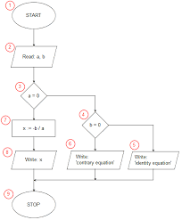

**3. Describe the Process Steps Through Pseudocode**

Here is the pseudocode that describes the process of solving ax+b=0:

Start

Input a, b

If a = 0 then

If b = 0 then

Print "Infinite solutions"

Else

Print "No solution"

EndIf

Else

x = -b / a

Print "The solution is x =", x

EndIf

End